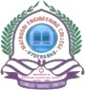
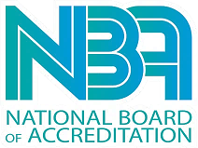
MATRUSRI ENGINEERING COLLEGE
(Approved by AICTE, Affiliated to Osmania University) (ISO 9001:2015 Certified Institution)
SAIDABAD, HYDERABAD – 500 059
ED-CELL MECS

The department of Mechanical engineering & ED-Cell conducted a Industrial Visit to “ALEAP” Industries Pragathi Nagar Kukatpally Hyderabad, under SPICES Program an AICTE Sponsored program to Stimulate and augment the entrepreneurial spirits and skills among students and to create new small and medium enterprises. Visit was organized on 17/12/2021. Around 64 students and 5 faculty members have visited the center.
ALEAP was the dream of women entrepreneurs, who wanted to train, guide, support and enhance the lives of other women. The Association of Lady Entrepreneurs of India (ALEAP) was established with an aim to bring Women Entrepreneurs trying to help each other. ALEAP’s aim is to make the women economically independent, through motivation, counselling, training and hand holding. Accordingly, during the last two decades, increasing number of women have entered the field of entrepreneurship and also they are gradually changing the face of economy of Telangana and Andhra Pradesh.
ALEAP also has established Center for Entrepreneurship cell .CED provides seamless service for promoting entrepreneurship movement with belief that entrepreneurs need not necessarily be born, but they can be trained and developed through well conceived and well directed intervention. CED is in associated with State Level Entrepreneurship Development Organizations, NGOs Voluntary Organizations, Educational Institutions, Financial Institutions, Business Associations

& EDI Ahmedabad. CED acts as a liaison between Government and Entrepreneurs by providing necessary information and consultancy services.
Students have visited various units like 1) Socks making unit 2) Polythene cover making unit using biodegradable material 3) Food processing unit4) Bio science lab 5) Logo printing on Jute cloth etc
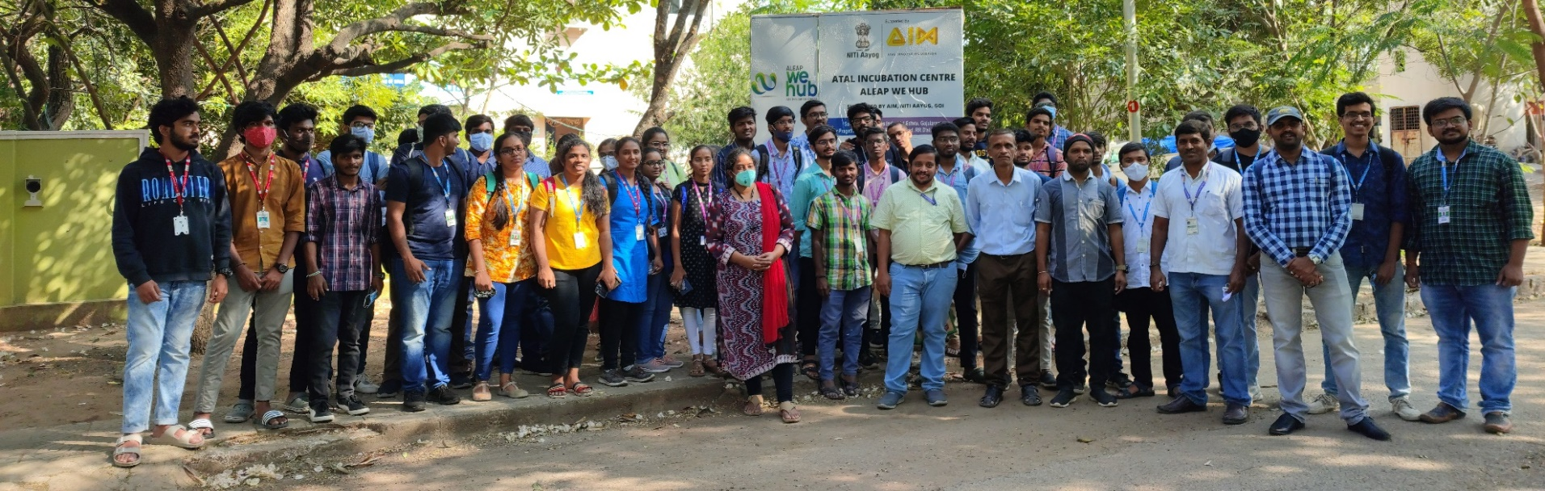

MECS SAE Collegiate & ED-Cell would like to thank our Principal Dr D Hanumanatha Rao Garu for his enthusiastic support. A special thanks to the Dr M V Kishore HOD MED and organizing committee, teaching staff for their unflinching support and coordination. Our heartfelt thanks to our students for active participation.
V.Harinath
ED-Cell Coordinator

